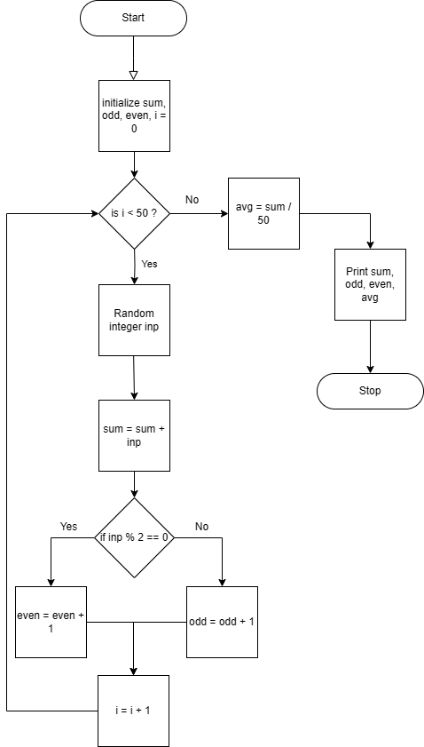**Flowchart**

**Algorithm(pseudocode)**

1. Start

2. Now initialize sum, odd, even, i = 0

3. Check condition: if i < 50 then go to step 4, else go to step 11

4. Random integer inp

5. Set sum = sum + inp

6. Check condition: if inp % 2 == 0 then go to step 7, else go to step 9

7. Set even <- even + 1

8. Go to step 10

9. Set odd <- odd + 1

10. i = i + 1, then go to step 3

11. Set avg = sum / 50

12. Print sum, odd, even, avg

13. Stop